E-Commerce Sales Analysis Project Questions.

Basic Analysis Questions.

1. What is the total revenue generated from all orders?
Total Revenue Generated = 44952975
Formula = SUM(Dateset!J2:J1001)

2. How many total orders are present in the dataset?
Total Order Count = 1000
Formula = =COUNTA(Dateset!A2:A1001)

3. What is the average order value?
Average Order Value = 44953
Formula = AVERAGE(J2:J1001)

4. Which product category generates the highest revenue?
Electronics generates the highest revenue.
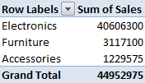
OR
Electronics Sales : 40606300
Formula = SUMIF(F2:F1001, K2, J2:J1001)
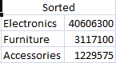

5. Which city has the highest number of orders?
Hyderabad has the highest number of orders.
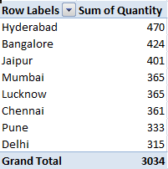
OR
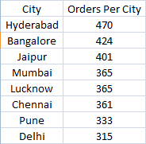
Formula = SUMIF(Table4[City], Analysis!A5, Table4[Quantity])

6. Which product is sold the most (highest quantity)?
Phone is sold the most (highest quantity).
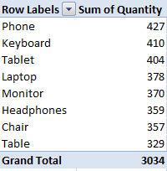
OR
Phone is sold the most.
Formula = SUMIF(Table4[Product], Analysis!A4, Table4[Quantity])

7. What is the total revenue generated from Electronics category?
Electronics Sales : 40606300
Formula = SUMIF(F2:F1001, N7, J2:J1001)

8. Which month has the highest sales revenue?
December has the highest sales revenue i.e. 4781050 Rs.
Formula for month column = TEXT([OrderDate], "mmmm")
Then use pivot table with month in Rows and Sum of Sales in
values then sort the whole table from largest to smallest.

9. Which city generates the lowest revenue?
Ans: Delhi generates the lowest revenue.
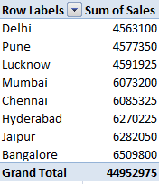
OR
Formula = SUMIF(Table4[City], Analysis!G4, Table4[Sales])
Then sort the whole mini table from smallest to largest.

10. What is the highest single order value in the dataset?
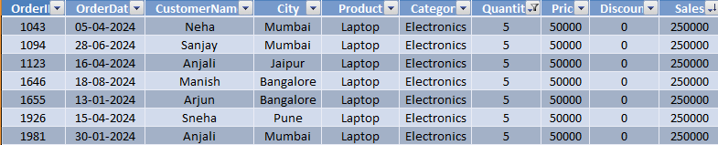

Intermediate Analysis Questions.

11. Which top 5 products generate the highest revenue?
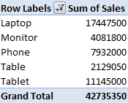
OR
The top five products that generate highest revenue are
Laptop, Tablet, Phone, Monitor and Table.
To get that answer first put all products in one column and
in the adjacent column use SUMIF function.
Formula = SUMIF(Table4[Product], Q12, Table4[Sales])

12. What is the total revenue generated by each city?
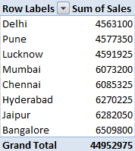
OR
SUMIF(Table4[City], R22, Table4[Sales])

13. Which category has the highest average order value?
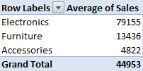
OR
Electronics = 79155
Formula = AVERAGEIF(Table4[Category], N17, Table4[Sales])

14. What percentage of total revenue comes from Electronics?
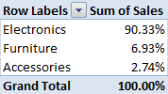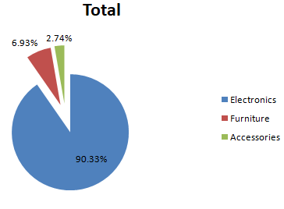
OR
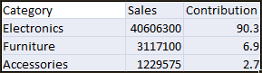
Formula = O22/SUM($O$22:$O$24)*100

15. Which month has the lowest sales?
February has the lowest sales.
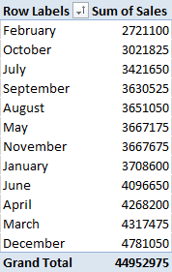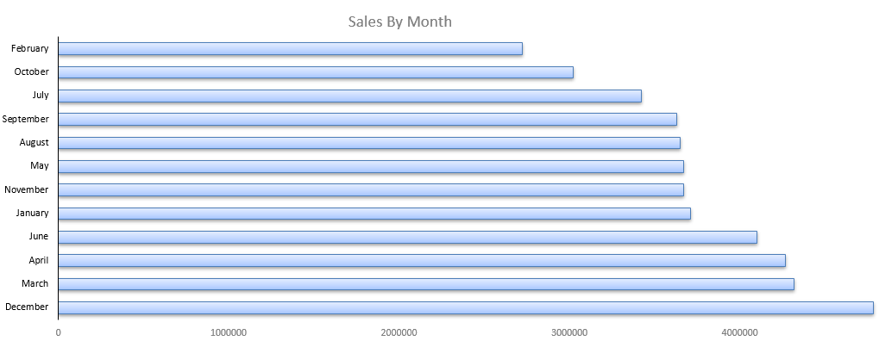

16. What is the average discount given per order?
Average Discount Value = 7.7%
Formula = ROUND(AVERAGE(Table4[Discount])*100, 2)&"%"

17. Which product category sells the highest quantity?
Electronics sells in the highest quantity i.e. 1579.
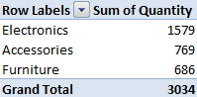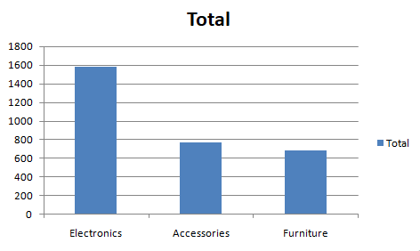
OR
Formula = SUMIF(Table4[Category], S2, Table4[Quantity])

18. Which city gives the highest revenue for Electronics products?
Bangalore with revenue of 5902400
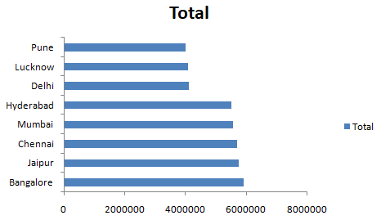
OR
Formula = SUMIFS(Table4[Sales], Table4[Category], $P$27,Table4[City], M30)

19. Which customer placed the highest value order?
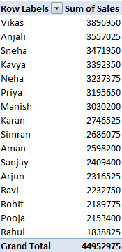
OR
Formula = SUMIF(Table4[CustomerName], T2, Table4[Sales])

20. What is the total discount amount given across all orders?
Total Discount Given Across All Orders is 3754025.
Formula = SUM(Table4[Price]*Table4[Quantity])-SUM(Table4[Sales])

Advanced Business Insight Questions

21. Which product category performs best in each city?
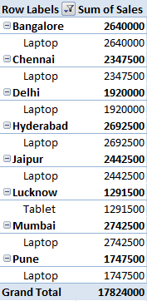
OR
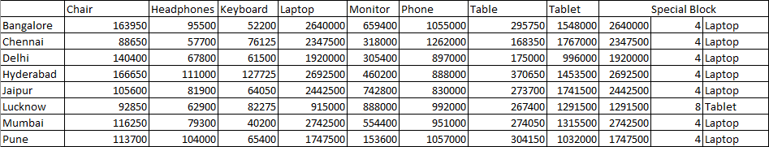
From above table we can see which product category performs best in each city.
Also, the formulas used to get the data under Special Block are:
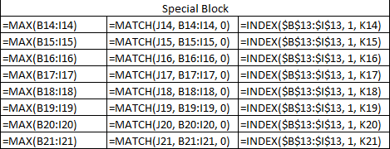

22. In which month do Electronics products sell the most?
In December electronics sell the most.
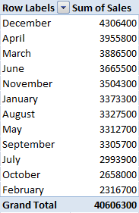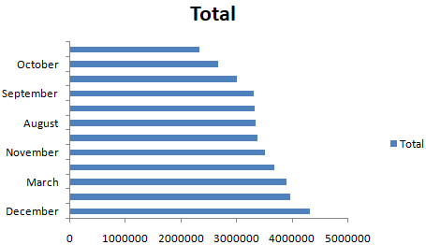
OR
Despite my best efforts the month formula, for month column refuses to work properly.
Only few months’ names are showing the rest aren’t.

23. Which product generates the highest revenue despite having discounts?
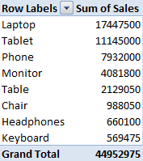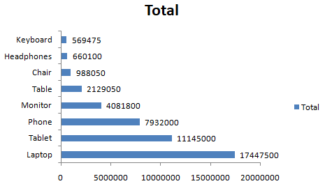
OR
Laptop generates the highest revenue despite having discounts. i.e. 17447500
Formula = SUMIF(Table4[Product], Q12, Table4[Sales])

24. Which city shows the most consistent sales throughout the year?
Variance = root(sum of ((Xi-x_mean)**2))/n)
Variance**2 = Standard Deviation
Hyderabad with standard deviation of 169631.71 (lowest)

25. What is the revenue contribution percentage of each category?
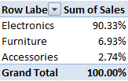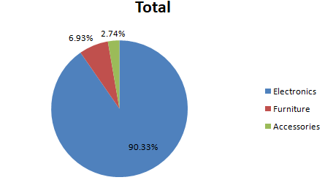
OR
Formula = ROUND(R31/SUM(Table4[Sales])*100, 1)&"%"

26. Which product has the highest average order value?
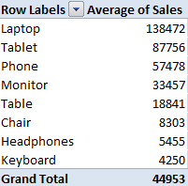
OR
Laptop has the highest average order value i.e. 138472
Formula = AVERAGEIF(Table4[Product], R33, Table4[Sales])

27. Which month shows the biggest sales growth compared to the previous month?
March with growth of around 59%.
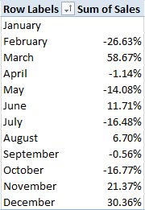

28. Which city contributes the most to total company revenue?
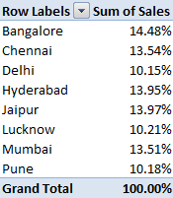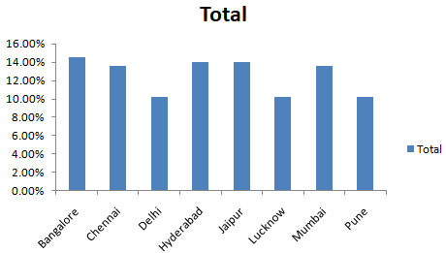

29. Which product category gives the lowest revenue but highest quantity sold?
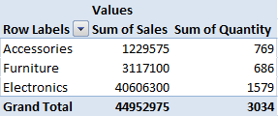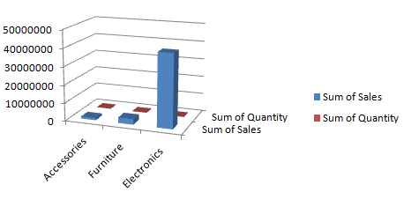

30. If the company wants to increase sales, which city and product combination should they focus on?
The combination of City: Mumbai and Product: Laptop has generated the highest sales, so company
should focus on this combination to increase sales.
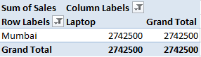
OR
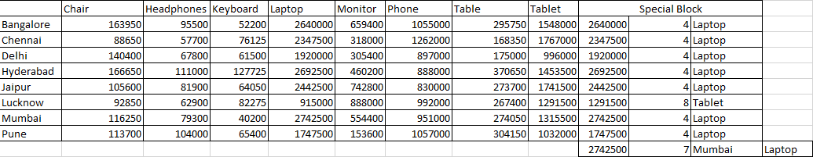

Formulas for Special Block are:
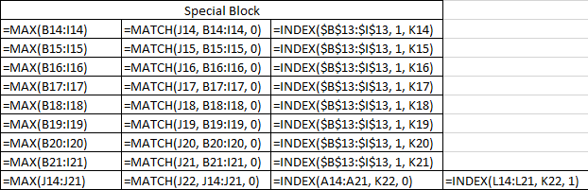

Dashboard Questions (Final)

31. Which category is the most profitable?
Electronics is the most profitable category.

32. What are the top 3 cities contributing to total sales?
Bangalore, Jaipur and Hyderabad.
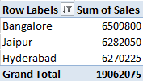

33. Which month shows peak sales activity?
March shows peak activity.

34. Which products should the company promote more?
Tablet is the product that should be promoted more by the company.

35. What business insights can you derive from this data?
In the month of March sales are at their highest. Category wise, electronics contributes the most.
Laptop in particular generates the highest revenue. Also, if you wish to improve sales further you
should focus on Laptops in Mumbai in particular and on Tablets in general.

